EXP : 9 Query with Joins – EquiJoin, InnerJoin, OuterJoin

Questions:
- List the departments where the faculty members are working.
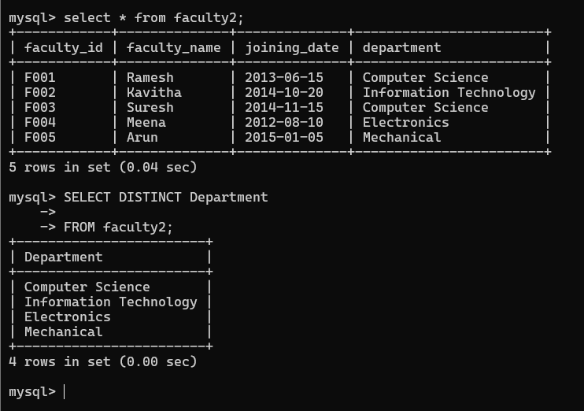
- Find the student who has no score in any of the courses. List student name and course number.
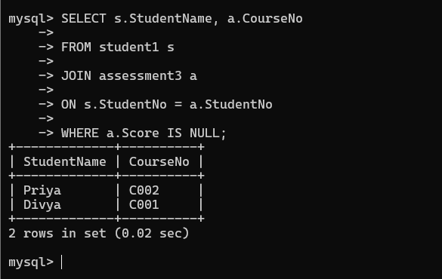
- The office clerk needs the names of the courses taken by the faculty belonging to ‘ECE department’ whose name is ‘Kamal’
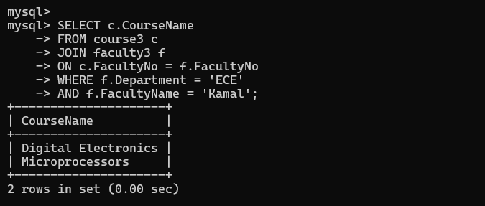

RESULT: The records from the tables are displayed using JOIN using EquiJoin, InnerJoin, OuterJoin.

